Diploma in Children’s Learning and Development
(Early Years Educator)
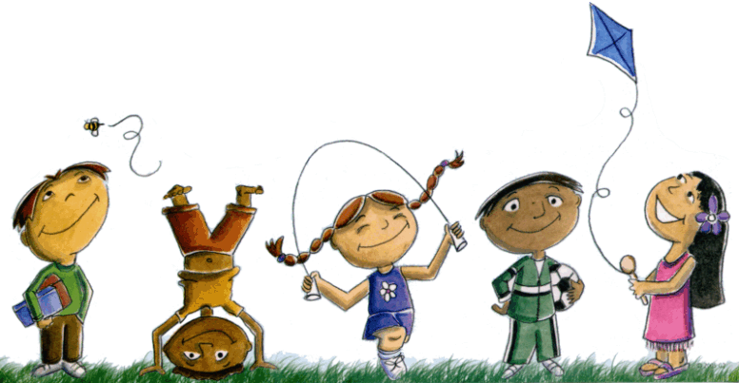
- Understand Children’s Early Years Education and Development – Unit 1
Once completed, this workbook provides evidence for the following:
Unit | Learning outcomes covered
1 | 1, 2, 3, 4, 5
8 | 1.3(EYFS)
9 | 1.2, 1.3, 2.1,
10 | 1.2

This workbook is about you and your role within your work setting. Please complete it using the format that best meets your needs. Please do not use real names.
Your assessor may identify that your answers have covered more Units and learning outcomes than those specified on the first page.
Candidate name…………………………………………….
Signature…………………………………………………….
Date………………………………………..……………………
Assessor name……………………………………..………
Signature………………………………………………………
Date……………………………………………………………….

Understand the patterns of children’s development from birth up to 8 years (1.1, 1.2, 1.3) (unit 10 1.2)
Explain the expected children’s development from 5 -8 years.

Literacy and numeracy: can count; uses well-informed sentences; can tell time/count money; can read on their own | 5-6 years  - can count;  - uses well-informed sentences;  - can tell time/count money;  - can read on their own
6-7 years
- can count;
- uses well-informed sentences;
- can tell time/count money;
- can read on their own
7-8 years
- can count;
- uses well-informed sentences;
- can tell time/count money;
- can read on their own

Physical: growth speeds up; develop fine motor skills; muscle coordination; permanent teeth appear; can copy complex shapes | 5-6 years  - growth speeds up;  - develop fine motor skills;  - muscle coordination;  - permanent teeth appear;  - can copy complex shapes
6-7 years
- growth speeds up;
- develop fine motor skills;
- muscle coordination;
- permanent teeth appear;
- can copy complex shapes
7-8 years
- growth speeds up;
- develop fine motor skills;
- muscle coordination;
- permanent teeth appear;
- can copy complex shapes

Emotional: confidence; personal identity, perception; independence; aware of own feelings; self-concept | 5-6 years  - Not very confident;  - No personal identity,  - Limited perception;  - Not independent;  - aware of own feelings;  - No self-concept
6-7 years
- Not very confident;
- No personal identity,
- Limited perception;
- Not independent;
- aware of own feelings;
- No self-concept
7-8 years
- confident;
- Has personal identity,
- Limited perception;
- Not independent;
- Aware of own feelings;
- No self-concept

How atypical development can impact areas of development
Case Study:
Amara’s condition: She’s taller than others in her class in her year; has hearing impairment and wears hearing aids. Other children setting passing comments on her size
- Should you do anything in this situation if Amara is not concerned?
Yes.
- What might be the effects of Amara’s condition within the setting?
- Increased children concentration about her condition
- Poor performance because of discrimination
- It can also affect their confidence and self-esteem causing problems building relationship with her classmates

How Children’s learning and development is affected by stage of development
Sequence of Development | Sequence of development is the normal sequence in which children learn different skills
Examples how Children’s learning and development is affected by stage of development | - Sensorimotor stage: children learn about the world using their senses and manipulating objects.  - Pre-operational stage: children learn around 10 new words a day and begin to understand emotions such as love, trust, and fear.  - Concrete operational stage: children learn to be less egocentric and self-centered.  - Formal operational stage: start to reason and think about abstract ideas, and implement these ideas into their lives.

Understand significance of attachment to children’s development
Theories on attachment to children’s development
- Attachment Theory (John Bowlby): states that a strong emotional and physical attachment to at least one primary caregiver is critical to personal development.

- Attachment behavior in children (Mary Ainsworth): the theory identifies three main attachment styles, secure (type B), insecure avoidant (type A) and insecure ambivalent/resistant (type C); and concluded that these attachment styles were the result of early interactions with the mother.
Why positive attachment is important
- Promotes positive and secure attachment between child and caregiver
- Creates a positive relationship between children and caregiver
- Provides positive feelings
How to promote positive attachment (with a new child)
- Play: promotes/provides positive feelings
- Being sensitive to child’s needs/feelings
- Avoid harming a baby’s and a child’s attachment
- Being comforted when they cry,

Importance to children’s holistic development (4.3)
Case Study:
Rosie, 4 years old, attends preschool, communication difficult to understand; other children cannot understand her ; she plays by herself
- Importance of early identification of speech, language and communication delays and disorders.
- The child can sooner receive the right treatment and support to hopefully correct the problem.
- Increasing the chances of improving their skills and
- Helping to get their development back on track as quickly as possible.
- Potential risks of late recognition of a speech delay
- It can lead to problems with understanding or a child being able to express their own feelings,
- It can leave children feeling angry or frustrated and causing them to act out and maybe develop behavior problems.
- It can also affect their confidence and self-esteem causing problems building relationships with peers

How to support children’s speech language and communication
Birth to 2 years | - Listening and trying to understand what they are saying  - Seeing a doctor if your child’s voice sounds different and it does not go away after a short time.
2 to 5 years | - Giving the child time to talk.  - Not interrupting or stoppingthe child while he speaks.  - Noticing if the child gets upset when stuttering.

Early intervention criteria
Different stages of early intervention where a child has a speech, language or communication difficulty

Direct Intervention
Indirect Intervention

Language/speech Therapist intervention

Meta-cognitive Approach

Comorbility

Role of professionals
Professional | Role and Responsibilities
SENCO | Overseeing the day-to-day operation of a school's special education policy, co-ordinating provision of policies, and communicating with parents of children with special educational needs.
Speech and Language Therapist | Provides treatment, support and care for children and adults who have difficulties with communication
Educational Psychologist | Help children or young people who are experiencing problems that hinder their successful learning and participation in school and other activities.

How integrated working practices deliver better outcomes for children
- Integrated practices have shown to improve their behaviour, social skills and learning.
- Ease the transition link between school and early learning years
- Children can experience personal and social benefits from attending integrated early years centres

3 Why it is important to work closely with speech and Language Therapist
- Speech and language therapists support schools to meet the needs of children with SLCN and in supporting good practice across universal, targeted and specialist approaches.
- Work with parents to support targeted interventions and support for children.
- They provide workforce development, including training, coaching and modelling support for other adults.

Systematic Synthetic Phonics
What is Systematic Synthetic Phonics  It is a method of teaching reading which first teaches the letter sounds and then builds up to blending these sounds together to achieve full pronunciation of whole words. | Association with Reading  It helps in synthesizing words from individual sound as an effective strategy for teaching children to read

Strategies for developing early literacy and mathematics
 | 4 examples of resources | What do they teach child to able to do?
Literacy | Songs  Objects  Voice inflections  Letter hunting | To remember letters/words  Running the object under each word as you read helps children develop a sense of orientation.  Voice inflections help children hear how reading should sound.  Improves child's letter recognition
Mathematics | Cards/puzzles  Tone/voice  Mixture of Objects  Songs | Analyze and make sense of information  Show size  Helps in sorting different shapes and sizes  Help child understand patterns

How play and activities are used to support the development of speech, language and communication (4.5)
- It enables them to enjoy learning
- Through watching they can remember
- Through imitation children can repeat the play

- How you would support a child through a transition
- What transition was, age and any changes to their behavior or development
- The effect on the child of having a positive relationship during period of transition

I would help a child through transition using play/games to create an attachment
Child, 7 years
Transition: From timid to confident
Through close association and attachment, the child opened up to me. Had low self-esteem but this later transformed and became for confident.

